

Walking & Cycling Strategy
For
County Monaghan
May 2017
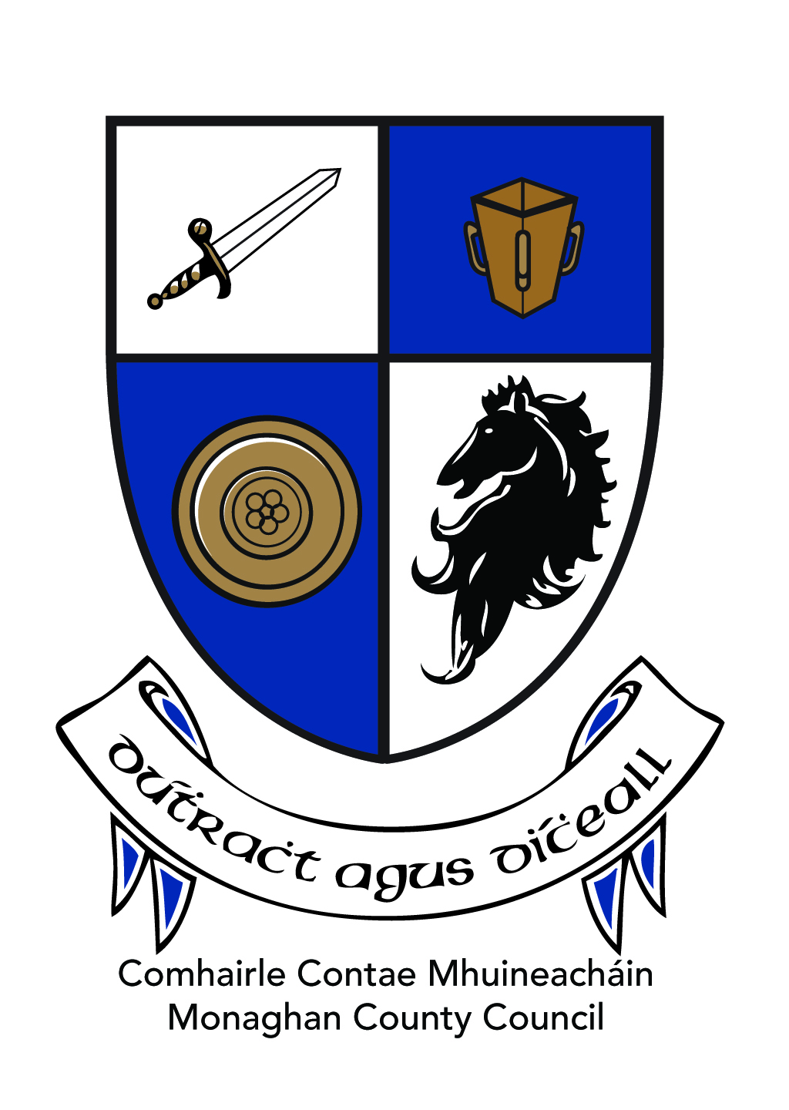

Monaghan County Council

Contents
1. Executive Summary 3
2. Overview 3
3. The County Today 4
3.1 County Overview 4
3.2 Current Status of Walking & Cycling in Co. Monaghan 4
3.2.1 Walking and Cycling for Recreation in Co Monaghan 4
3.2.2 Walking or Cycling as a Commuter in Co. Monaghan 10
4. The Strategy 15
4.1 Key Policy Areas 15
Road Safety 15
Recreation & Amenity 15
Tourism 15
Road Design 15
Accessibility 15
Sustainable Transport 15
4.2 Key Actions 17
4.2 Implementation 19
Appendix: The Rationale behind our Strategy 19
Strategic Framework 20
Age Friendly Agenda 21
Healthy Lifestyles 22
National Policy 22

Executive Summary

Overview

2.1 Background to the Strategy
This Strategy has been developed by Monaghan County Council, as a consequence of ongoing work being undertaken by the Council’s roads, planning, tourism and community Depts as well as within the towns of Monaghan, Castleblayney and Carrickmacross, and in response to the increasing demand from the public and the community sector for more walking and cycling infrastructure and amenities, both to facilitate leisure activity and commuting.
It builds on the work commenced in 2012 when Walking & Cycling Strategies for the towns of Castleblayney and Monaghan. A similar Strategy is being completed in Carrickmacross in 2017. It also builds on the success of the Ulster Canal Greenway Phase I project, which opened a 4.2km section through Monaghan town in 2014 and is used by almost 100,000 people annually.

2.2 Strategy Contents
The Strategy records the existing walking and cycling infrastructure and supports in the county, and outlines how these will be enhanced over the coming years to provide for the recreational and commuting needs of the people of County Monaghan.
The document is a high-level strategic look at how Monaghan County Council proposes to provide an effective mix of hard and soft supports to achieve two core objectives, namely:
- Enhance the well-being of the people of Co. Monaghan
- Contribute to the government’s targets on sustainable transport, by encouraging more commuters to ditch the private motor car in favour of walking and cycling for at least some of their journeys (ie achieve a modal shift)

2.3 Rationale for the Strategy
Monaghan County Council is committed to the goals of the Dept of Transport Tourism & Sport’s (DTTAS) Smarter Travel programme. We have been incorporating cycling infrastructure into our roads and street plans for a number of years, and a commitment to the promotion of the Smarter Travel agenda is included in the County Development Plan 2013-2019.
The Council has also been supporting a number of community groups to develop local walking routes, and has been developing and maintaining a number of walking and cycling trails itself.
The purpose of this Strategy is to provide the framework into which all present and future projects may be slotted, showing how they connect to a coherent network, and contribute to the overall vision. In this way, the Council will be sure that it is getting the best from its resources at all times, putting the right infrastructure in the right place and connecting to an overall network rather than leaving a project standing out on its own.
The Strategy will outline the main tools/ programmes that it foresees being used in helping the Council to implement its vision for the county. However, it is beyond the scope of this Strategy to put forward detailed plans or costings for individual projects at this point.

The County Today

3.1 County Overview
According to Census 2011, there were 60,483 people living in Co Monaghan in 2011. This had grown to 61,386 in the Census of 2016, an increase of 1.5%.
The county is located in the North East, and is surrounded on three sides by Northern Ireland. There is no rail service to the county, and the main traffic is taken by the one National route, the N2, which cuts through the county from north to south. There is 2,408.97 kilometres of public road in Co. Monaghan of which 107 km is national road. The network of local roads is one of the most dense in Europe. Public transport services operate along the N2, and also across the county using regional routes.
County Monaghan is a very rural county, with over 70% of the population living outside its five urban areas. Of the 1.5% increased population recorded in the 2016 Census of Population, 225 people chose to live in our urban centres, while 675 settled in the rural areas. It is clear therefore that the county’s traditional rural settlement pattern is set to continue into the future.
This poses unique challenges to the promotion of the Smarter Travel agenda, as for many people, travel by private motor car is the only practical option available to them at present in the rural areas.
The rolling drumlins and small fields edged with hawthorn hedges together with its many lakes make Co Monaghan’s countryside a spectacular place to go walking or cycling. We also have one of the most dense networks of minor roads in Europe, many of which may lend themselves to development for recreational walking and cycling.

3.2 Current Status of Walking & Cycling in Co. Monaghan

Walking and cycling must be considered in two distinct ways for the purpose of this Strategy:
- As recreational activities. People walk and cycle for leisure and for their health and well-being. They also increasingly popular activities to participate in as part of a trip away, and are considered trip attractors for a tourism destination, eg the Great Western Greenway.
- As essential means for getting around. As such, walking and cycling are part of the commuting picture, and the Council must consider solutions which enable commuters to choose to walk or cycle instead of using the motor car. Walking and cycling are sustainable forms of transportation, and are an important part of the Council’s commitment to promoting sustainable development in general and smarter travel in particular.

3.2.1 Walking and Cycling for Recreation in Co Monaghan

A number of recreational trails have been developed in the county. The first to be developed were the trails within the Coillte-owned forestries, most notably Rossmore Forest Park on the edge of Monaghan town. There are walking trails also in Dartrey Forest which stretches from Rockcorry to Cootehill, Muckno in Castleblayney and Billy Fox Memorial Park in Bawn. All offer free access to the public. Monaghan County Council has recently leased Rossmore Forest Park from Coillte and is in the process of developing a management plan and upgrading the trails and other amenities therein.
There is a strong tradition of community development in the area of trails development. In 2001, a community-led initiative developed the county’s first way-marked long distance walk, from Inniskeen to Clontibret. Once complete, the maintenance and insurance of the route was taken on by Monaghan County Council.
Trail Name | Trail type | Length | Location
Kingfisher | On Road Cycling | 35 km | Clones, Newbliss, Scotshouse
Monaghan Slí | Sli Na Slainte Walking Routes | 2.5 km | Monaghan Town
Monaghan Way | Walking/Hiking | 56.5 | Monaghan Town, Castleblayney, Inniskeen
Rossmore Lake Trail | Walking/Hiking | 8 km | Monaghan Town
St. Davnet’s Hospital Slí | Sli Na Slainte Walking Routes | 1.5 km | Monaghan Town
Ulster Canal Greenway | Greenway | 4.2km | Monaghan Town

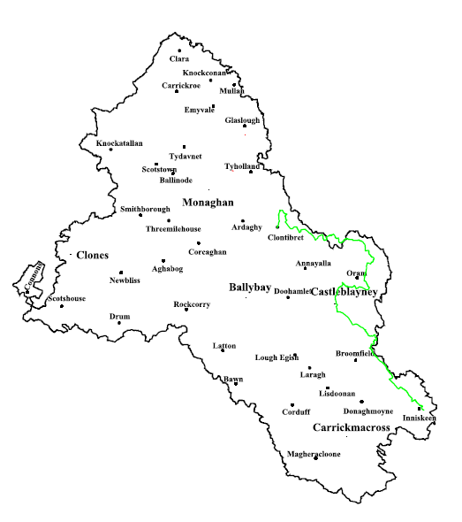
Other community-led initiatives include:
- Donagh Development Committee developed a walk around Emy Lough in North Monaghan, with funding from LEADER
- Knockatallon Development, together with Clones Erne East Partnership, developed a series of cross border walks across Sliabh Beagh and Bragan mountain
- Clones Development Society developed a local loop off the Sustrans long distance Kingfisher Cycle Trail
- Blackwater Regional Partnership developed an on-road Ulster Canal Cycle Trail which starts at Caledon, travels through Glaslough and Monaghan and connects across Threemilehouse and Scotshouse to join the Kingfisher trail at Clones.
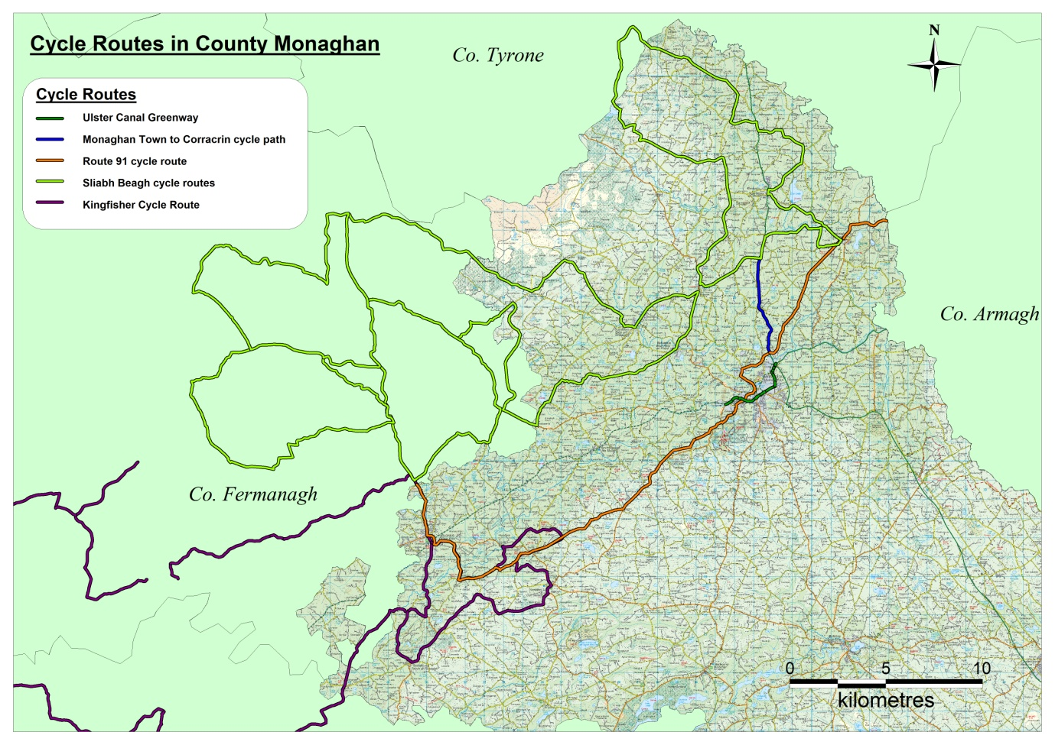
There are two Slí na Sláinte routes in the county. These are in-town local routes designed to encourage people to take short walks for the good of their health, and are an Irish Heart Foundation initiative. Both routes are located in Monaghan town, one around St Davnet’s complex, owned by the HSE, and the other around Mullaghmatt housing estate.
With the roads becoming busier, and more people becoming active for the sake of their health, community groups are becoming concerned with the safety of pedestrians on rural roads. A number of GAA clubs have built walking tracks around their training fields to accommodate walking in dark winter evenings.
Monaghan County Council has in recent years become more active in developing walking and infrastructure, notably the walk connecting the town park in Ballybay to Lough Mor Avenue, the Convent Avenue Walk in Carrickmacross, and the Ulster Canal Greenway through Monaghan Town.
Cycling infrastructure is still in its infancy in Co. Monaghan. Monaghan County Council dipped its toe in the waters of designing cycling infrastructure with the provision of a pathway for vulnerable road users to the side of the realigned N2 from Monaghan to Coracrin. Provision of cycle paths within the towns is challenging, due to the narrowness of the streets.
In 2011, the Council availed of Dept of Transport funding to provide cycle parking facilities at key locations at every town and village, and at every community centre around the county. The following year saw the commissioning of the first walking & cycling strategies in the county, for the towns of Monaghan and Castleblayney. These strategies included detailed plans and costings for proposed changes to streets in order to provide for cycle lanes.
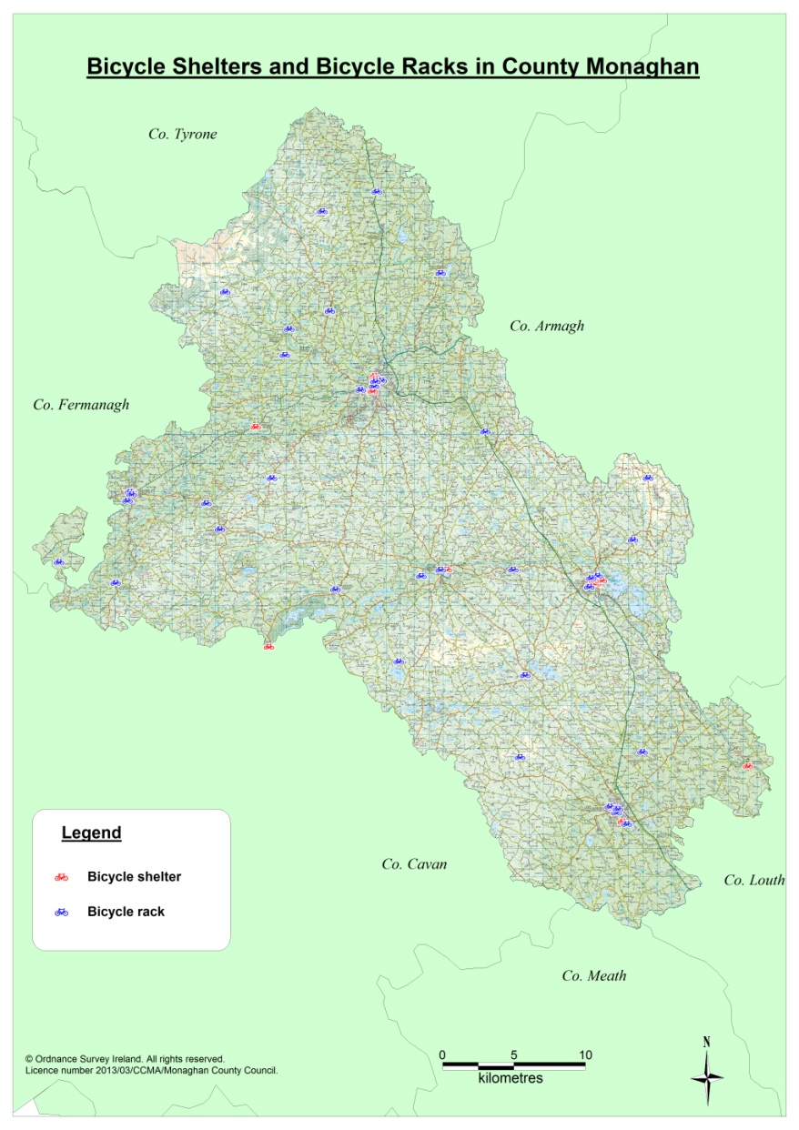
The county’s first Greenway opened in November 2013. The Ulster Canal Greenway (Phase I) traverses Monaghan town and provides a central spine into which the cycling infrastructure which is planned for the town will eventually connect.
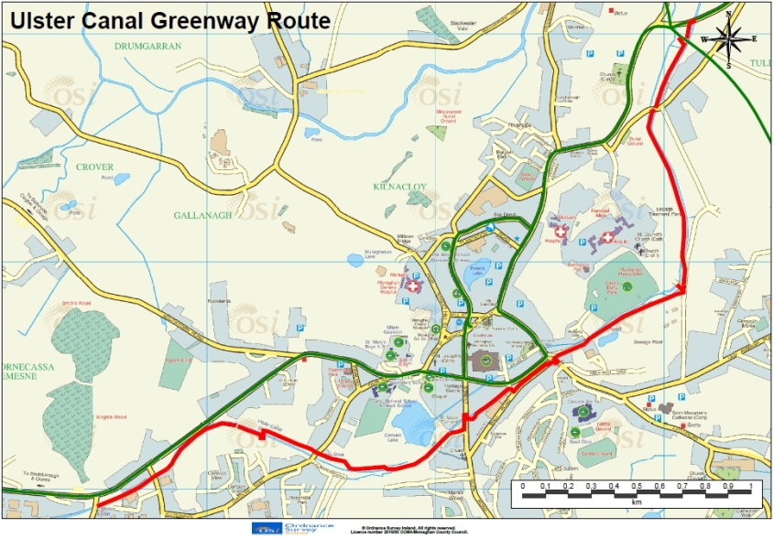
Monaghan County Council has developed a partnership with Waterways Ireland, Armagh City Banbridge & Craigavon Borough Council, Cavan County Council, Fermanagh & Omagh Council and Mid Ulster Council to develop a long-distance Greenway using the entire length of the Ulster Canal and several disused railway lines to connect the main population centres throughout the mid Ulster region, including Cavan, Enniskillen, Lisnaskea, Newtownbutler, Clones, Monaghan, Armagh and Portadown. Funding for Phase II of the route (Phase I being the completed stage through Monaghan town) has been secured from the INTERREG VA programme and this section is expected to open by mid 2020.
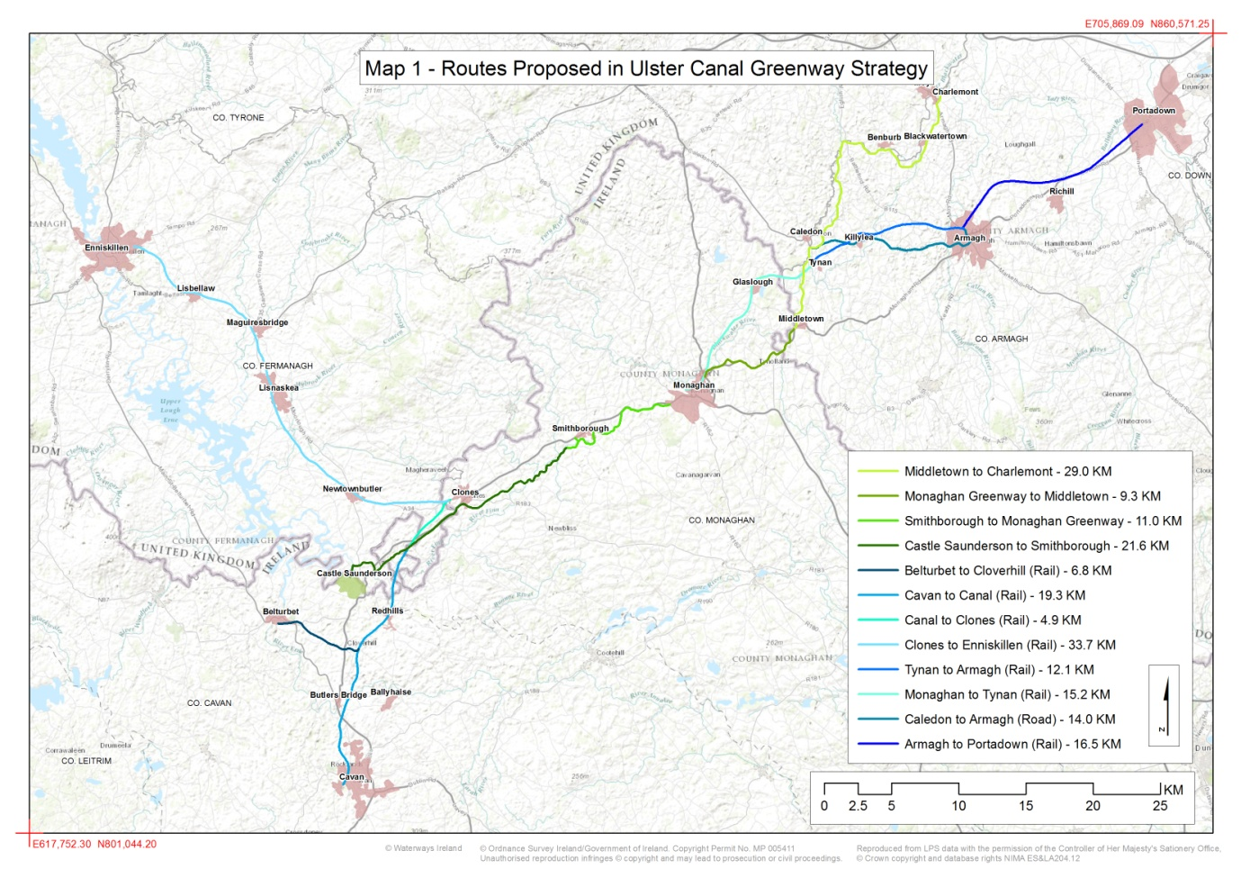
There are a number of walking clubs in the county, catering for every age and level of fitness. The clubs include:
- Knockatallon Ramblers
- Toome TCG Walking Group
- Rooskey Vale Walkers
- Emy Early Birds
- Farney Ramblers
- Clones Walkers
- Rockcorry Walking Group
- Monaghan Walkie Talkers
- Over 55’s walking club Monaghan town
There are five cycling clubs in the County, namely:
- Carrickmacross Cycle Club
- Clones Cycle Club
- Emyvale Cycle Club
- Killylough Cycle Club
- Four Counties Cycle Club
Walking and cycling events and festivals which take place annually in the county include:
- U3A’s walking festival in Monaghan town in February
- Boots ‘n’ Bogs festival on Sliabh Beagh in March
- Blackwater 10k walk/ run in Rossmore Park in May
- National Bike Week in June - a week long series of events co-ordinated by Monaghan Sports Partnership and funded by the Dept of Transport Tourism & Sport
An Taisce’s Green Flag initiative is well established in the county, and seventeen schools have completed their Transportation (4th) Flag. Walk/ Cycle on Wednesdays events are a regular feature of school life for participating schools in the Green Flag family.
The schools which have achieved their green flag for Travel are:
- Ballybay Central School, Ballybay
- Broomfield NS, Broomfield
- Bunscoil Lughaidg Naofa, Carrickmacross
- Clontibret NS, Clontibret
- Our Lady’s Secondary School, Castleblayney
- Scoil Mhuire, Smithboro
- Scoil Mhuire, Glaslough
- Scoil Mhuire Boys, Castleblayney
- Scoil Mhuire Clontibret, Clonitbret
- Scoil na gCailni, Castleblayney
- Scoil Naomh Padraig, Emyvale
- Scoil Padraig, Carrickmacross
- St.Tiarnach’s Primary School, Clones
- Scoil Mhuire Latton, Smithborough,
- St.Mary’s BNS, Monaghan,
- St.Michael’s, Rackwallace,
- The Central School, Castleblayney

The schools which hope to achieve it in 2018 are:
- Knockconan NS, Knockconan,
- 2. Scoil Blaithin Iosa, Ballygearan,
- 3. Scoil Eanna, Ballybay,
- 4. St.Louis Infant, Monaghan

3.2.2 Walking or Cycling as a Commuter in Co. Monaghan

(Transportation and commuting data from Census 2016 will not be released by the CSO until July & August 2017. These will be analysed at that time, and the draft Strategy adjusted if necessary to take account of any relevant data)
According to Census 2011, 36,262 people travelled to work or school each day, with 22,171 of these making their journey by private motor car. Only 150 people completed their journey by bike!
In terms of journey times, 41% of commuters in Co. Monaghan are making a journey of less than 15 minutes. This suggests that there is significant potential amongst this cohort to generate a shift away from the motor car as the primary means of transportation towards more sustainable modes of transportation, for at least some of their daily journeys.
Population aged 5 years and over by means of travel to work, school or college
On foot | 3,843
Bicycle | 150
Bus, minibus or coach | 4,231
Train, DART or LUAS | 67
Motorcycle or scooter | 28
Car driver | 14,783
Car passenger | 7,388
Van | 2,684
Other | 2,133
Not stated | 955
Total | 36,262

14,297 people make a journey of less than 15 minutes to their workplace or school. This would indicate that walking or cycling is a viable alternative to the motor car for many.
Population aged 5 years and over by journey time to work, school or college
Under 15 mins | 14,297
1/4 hour - under 1/2 hour | 10,034
1/2 hour - under 3/4 hour | 4,582
3/4 hour - under 1 hour | 1,388
1 hour - under 1 1/2 hours | 1,260
1 1/2 hours and over | 870
Not stated | 2,087
Total | 34,518

3.4 Levels of Walking & Cycling in Co. Monaghan

A baseline survey of the levels of cycling and walking in Monaghan town in 2012, carried out prior to the opening of the Ulster Canal Greenway, confirmed the very low rates of walking and cycling seen in CSO commuting data followed through to general behaviour. However, a follow-up survey conducted twelve months later showed a remarkable change in attitude in favour of walking and cycling following the opening of the Greenway, with a much higher proportion of respondents now indicating that they intended to walk or cycle regularly.
This followed through to a change in actual behaviour, with the amount of people walking and cycling for health and fitness motives up from 39% in 2013 to 69% in 2014. This demonstrates that behavioural change is possible if the infrastructure is put in place.
A public consultation was carried out in spring 2017 as part of the process of preparing a walking & cycling strategy for Carrickmacross. An online survey was conducted as part of the consultation. When asked why people generally walk, the majority of people said that they walk for leisure or fitness (65%). People were asked what would encourage them to walk more often. 51% said better footpath provision would encourage them to walk more. More pedestrian crossing points and someone to walk with were other key items. Other suggestions included better lighting, less dog faeces on the footpaths, designated walking paths and less HGV’s in the town environs.
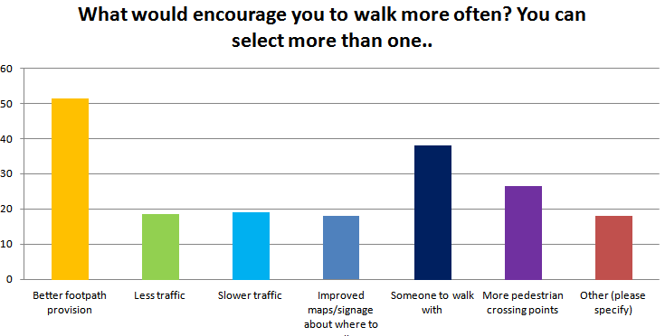
Cycling in the town is not a common mode of transportation. The survey indicated that people generally cycle for leisure and fitness purposes with most respondents cycling distances of between 2km and 5km.

3.5 Barriers to Walking & Cycling in Co Monaghan

In 2013, as part of the baseline survey of walking and cycling levels in Monaghan town, a survey of 100 people was carried out on the streets of the town. Respondents who said they weren’t frequent walkers or cyclists were asked why they did not walk or cycle more.
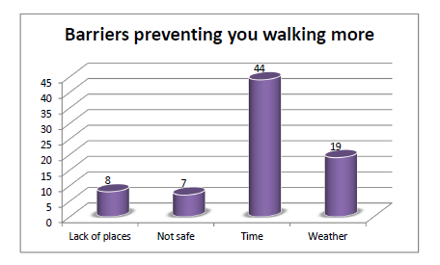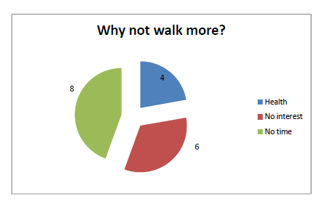
The majority of people interviewed felt that there were no specific physical barriers to walking or cycling in the town, which is good news. Where respondents felt there was a barrier, almost half identified traffic to be the biggest deterrent to their walking more.
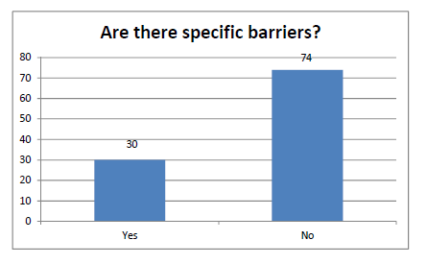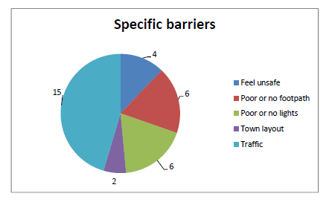
The lack of cycle lanes was seen as the biggest barrier to cycling within the town, followed by the amount of traffic and motorist behaviour.
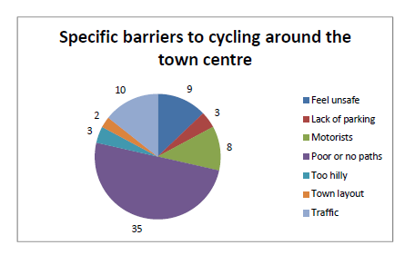
In the 2017 survey of Carrickmacross, the lack of cycle lanes in the town was a major issue for many of those surveyed. Safer routes were also suggested.
The lack of cycle lanes is common to all towns in the county, as is the presence of heavy volumes of traffic at peak periods, and large numbers of HGV’s in the town centres sharing narrow streets with cyclists.
For recreational walkers, access to the countryside is an issue throughout Ireland, as the country does not have commons land or bridle paths such as exist in the UK. However, the use of permissive access and way leave agreement, along with the foresight of Monaghan County Council in acquiring a considerable length of the Ulster Canal in the 1980’s under the Derelict Sites Act, mean that there are some options which can be explored.
The public liability insurance cost of is a barrier to the development and maintenance of many routes for community groups, and may become an issue in the future for the Council, should there be a court judgement on a similar amenity elsewhere in the country.

3.6 Council Promotion of Walking & Cycling
Monaghan County Council supports walking and cycling activity, and commuting by foot and bike presently by:
- Participating in National Bike Week each year. We co-ordinate community-run cycling-themed events around the county.
- We have appointed a Cycling Officer, who acts as a point of contact for all cycling matters within the Council
- Walking and cycling form an important part of the programme of Monaghan Sports Partnership, which is housed under the umbrella of the Council
- Provision for cyclists has been designed into our most recent major roads projects, such as the N2 realignment from Monaghan to Corracrin
- We insure and maintain a number of community-initiated trails, such as the Monaghan Way
- We fund a number of events, such as the Blackwater 10k, which takes place annually in Rossmore Forest Park
- We have developed town parks in Ballybay and Clones, and provided walking amenities in both
- We have leased Rossmore Forest Park from Coillte and upgraded all walks within the park. Further improvements to the amenity are planned
- Walks to our property at Muckno Park have likewise been created
- We have worked with local communities to provide footpaths and lighting in rural areas which are being used regularly as local walking ‘loops’
- Cycle parking is provided in town centres and in every village
The County Development Plan 2013-2019 includes the following objective under Transportation:
“Promote and facilitate the use of cycling and walking as alternative sustainable modes of transport in accordance with the provisions of the National Cycle Policy Framework 2009-2020.”

In the Development of Community Infrastructure section, a whole section is devoted to Cycling and Walking, as follows:
Objectives for Cycling and Walking
CWO 1 | Ensure that all plans and projects relating to the provision of cycling and walking facilities are subject to policies AAP1-AAP5 contained within Chapter 4, Environment and Heritage, of the Monaghan County Development Plan 2013-2019.
CWO 2 | Support, promote and facilitate walking and cycling as alternative modes of transport in appropriate locations throughout the county.
CWO 3 | Develop a walking and cycling strategy for the County during the lifetime of the plan.
CWO 4 | Support, promote and encourage the development and maintenance of looped walks, and long and medium distance walking and cycling routes (including long and medium distance trails) throughout the county in line with the Government’s Smarter Travel Policy, particularly those which have cultural or historic association, which provide linkages with trails to existing established national, and local and cross border walking/cycling routes.
CWO 5 | Protect established walking routes from development which would adversely impact upon them.
CWO 6 | Identify safe and convenient walking and cycle routes in urban areas and between the main towns and villages in the county, and provide signage and ancillary facilities at appropriate locations to promote their use, during the lifetime of the plan.
Policies for Cycling and Walking
Any development providing jobs, shopping, leisure and or services, including education and community uses should take into account the needs of cyclists and pedestrians. Where appropriate, provision of the following will be required:
CWP 1 | Safe and convenient pedestrian and cycle access, and accessible pedestrian crossing policy developed under the Disability Act.
CWP 2 | Safe, convenient and secure cycle parking and ancillary/associated facilities.
CWP 3 | Safe and convenient pedestrian and cycle links to existing or programmed networks (including existing applications) where they adjoin the development site, using the accessible pedestrian crossing policy developed under the Disability Act.

The promotion of Walking and cycling helps the Council to deliver on a number of key programme areas, including:
- Smarter Travel
- Sustainable Development
- Roads & Infrastructure
- Town planning
- Tourism development & promotion
- Age Friendly initiative
- Recreation & Amenity provision
- Health promotion
- Community development
The development of walking and cycling facilities, and the promotion of walking and cycling in the county will assist the Council to deliver a high quality environment and standard of living for the people of Co. Monaghan, and therefore we are committed to incorporating walking and cycling into our work at every opportunity.

The Strategy

4.1 Key Policy Areas
Monaghan County Council proposes to adopt the following policies:

Road Safety
- In the interest of safety, we will seek to deter the public from walking on public roads where there has been no footpath provided for this purpose
- We will support communities which wish to provide safe, off-road walking amenities in their area

Recreation & Amenity
- Monaghan County Council is a key provider of public recreational spaces in the county. We commit to creating as many spaces as possible throughout the county, and ensuring that they are suitable for walking and cycling

Tourism
- Monaghan County Council recognises the potential of walking and cycling as tourism products. We will seek to develop infrastructure of significant scale, so as to act as trip attractors to the county
  - In particular, we will seek to develop the following Greenways, in collaboration with our neighbouring Councils and other partners:
    - Ulster Canal Greenway (Clones-Smithboro-Monaghan-Middletown)
    - Border Kingdoms Greenway (Kingscourt-Carrickmacross-Inniskeen-Dundalk)
- We will work with clubs & tourism providers to develop a programme of walking and cycling festivals throughout the year, to showcase our infrastructure

Road Design
- We will seek to incorporate walking and cycling-friendly design into all new road design projects
- Where road width does not allow for segregation of cyclists from other traffic, Monaghan County Council will seek to either:
  - lower the general speed limit, or
  - restrict the number and/or size of vehicles using a street at any one time,
so that cyclists and traffic may safely share the same space

Accessibility
- Monaghan is an Age Friendly county. We will ensure that walking and cycling infrastructure is age friendly
- Walking and cycling infrastructure and programmes will be designed with the needs of people with disabilities in mind at all times

Sustainable Transport
- We will promote the Smarter Travel message and work to encourage more commuters to ditch the motor car and complete at least the last part of their journey by bike or on foot
- We will develop Walking & Cycling Plans for each town & implement as funding allows
- We will develop car parks on the edge of the larger towns to facilitate commuters to park and cycle/ walk, and encourage schools to develop walking bus systems from these locations
- We will maintain the GoMonaghan brand & website (already in place) to promote all things sustainable transport around the county
- We will work with schools and businesses to put Active Travel Plans in place to assist them to achieve behavioural change. We will work to connect them physically into the network of footpaths and cycle paths

4.2 High Level Actions
The following High Level Actions give the Council a framework into which we will slot our future activity regarding the development of walking and cycling infrastructure and the promotion of walking and cycling activity in the county. They give shape to the ‘WHY’ and put a start on the ‘HOW’. As we move forward, we will develop more detailed Action Plans for each town, and within specific areas of activity such as Tourism, which will put further shape on the work.
Where it has been possible at the time of writing this Strategy to identify how we will push an action forward, this has been detailed in the right hand column. The precise timing of the roll-out of some actions will depend on the availability of funding.
This table outlines the High Level Actions of the Strategy and proposed pathway to implementation of the key policy areas:
Policy Area | Action | How it will be achieved
1.Road Safety | 1.1 Deter public from walking along roadside  1.2 Support to groups in developing off-road routes | Publicity campaign  Notices on popular routes  Advice from community development staff, funding through Community & Environment Grant
2. Recreation & Amenity | 2.1 Develop new parks  2.2 Upgrade & extend trails in existing parks | Collaboration with local communities  Eg. Scotshouse Park  Availing of funding programmes such as CLÁR
3.Tourism | 3.1 Develop large off-road trails:  - Ulster Canal Greenway  - Border Kingdoms Greenway  3.2 Upgrade Monaghan Way & extend from Clontibret to connect with Ulster Canal Greenway at Armagh border  3.3 Upgrade Sliabh Beagh walks  3.4 Develop walking festivals programme | Smithboro to Middletown underway. Open by mid 2020  Scoping study 2017.  Kingscourt to CMX to be mapped 2017 & completed 2018  CMX to Inniskeen 2020-2024  Inniskeen to Dundalk 2018-2022  Map route 2017/18  Seek funding 2018  Complete project by 2022  Funding in place. Work completed by end 2020.  Bring existing festivals together in one calendar of events. Publicise together. Develop new event around extended Greenway & promote all as one – 2020
4.Road Design | 4.1 New roads projects – design provision for vulnerable road users into hard shoulder  4.2 Introduce cycle lanes in towns | Roads design team to draft design, with reference to National Cycle Manual & in consultation with Transport Infrastructure Ireland  Public consultation required for any proposals involving changing the layout of streets, eg losing car parking, reducing speed limits. Likely to be introduced on a whole-town basis, and need major funding to do all measures at once. Otherwise, lanes likely to cause problems if they abandon cyclists suddenly ‘because funding ran out halfway through town’
5.Accessibility | 4.1 Ensure the needs of older people and people with disabilities are properly considered at the design stage for all new amenities, and built in to the tendering process on all construction tendering  4.2 Promote the Age Friendly agenda and disability awareness through visible design elements along walking and cycling infrastructure | Designers asked to consider accessibility at design stage. Points awarded for this criteria during assessment of tenders , as per MCC’s accessible tendering guidelines  Signage, seating etc can reinforce the message and help to raise public awareness of these important issues
6.Sustainable Transport | 6.1 Promote the Smarter Travel message  6.2 Develop & implement walking & cycling plans for each town  6.3 Develop Car Parks for commuters at edge of our commuter towns  6.4 Promote GoMonaghan brand  6.5 Active Travel Plans for businesses and schools | Continue to engage a Cycling Officer & roll out a Smarter Travel community engagement programme  Monaghan & Blayney plans in place.  Carrick plan underway. Will be complete end 2017  Ballybay and Clones by 2019  Monaghan town by end 2019  Carrickmacross 2021  Continue to update website & roll out promotional events & materials as part of community engagement programme  Start with Monaghan town. All schools and 20 businesses to have plans in place by end 2019

4.3 Implementation
Our Strategy has two strands:
- Actions which are within our direct control to deliver in full
- Actions which will depend on how successful we can be in influencing others to change
Monaghan County Council will be responsible for carrying out much of the infrastructural work directly. We will use a combination of our own resources (staffing and funds) and external funding to achieve the outcomes. While all of the actions identified in our Strategy are achievable, the pace of their implementation will be realised much sooner, particularly for the larger infrastructural projects, should we be successful in securing funding from outside sources.
The Council will also play a key role in influencing people to change, through the work of our Cycling Officer and the roll-out of our Smarter Travel Community Engagement Plan, which seeks to promote a change in commuter behaviour and promote walking and cycling in general.
The Community Engagement Plan is a two-year programme of work which is tied in to the Ulster Canal Greenway Phase II project. It will focus on the schools and businesses along the corridor of the greenway, ie Smithboro to Middletown. Funding has already been secured for this programme. Whilst the project will work directly with schools, communities and businesses along the route of the Greenway, the impact of the project will be felt by a much wider area, and the learning from the programme will remain with the Council staff beyond the lifetime of the programme, thus benefiting the county far beyond the lifetime of the project itself.

Monitoring & Evaluation
A Strategy is meaningless unless you can see if it is working! In the case of our Walking & Cycling Strategy, success would mean:
- More people using the recreational trails in Co. Monaghan
- More people cycling in our towns
- More people commuting by foot and bike
We will measure these by:
- Installing pedestrian and cycle counters on Council-managed trails
- Carrying out periodic traffic counts in the towns
- Carrying out periodic cycle parking counts at schools and cycle shelters
- Conducting an attitudinal survey every five years, to track the change in public sentiment towards walking and cycling, and the Council’s performance.
An Active Travel Task committee will meet every six months to keep progress under review. Membership of the Committee will include representation from the Road Design team, the Planning Section, the Public Participation Network, the Social Inclusion Unit, the Environmental Awareness Unit, the Sports Partnership, Monaghan Tourism, the Road Safety Officer and the Cycling Officer.

Appendix: The Rationale behind our Strategy

We have based our Strategy on sound national and international policies and practices, and in consideration of national, regional and local programmes. The main programmes and policies taken into consideration are summarised in this section.

Strategic Framework
As far back as 2002, the importance of sustainable living and how it can impact on quality of life was acknowledged by the people of Co Monaghan.

The “Shared Vision for Monaghan”, the County Development Board’s Integrated Strategy for Monaghan 2002-2012, stated that:

“Monaghan is an inclusive, outward-looking, progressive county, which enjoys a diverse, vibrant economy, a sustainable environment and a high quality of life for all.”
Monaghan town was given ‘Hub’ designation under the National Spatial Strategy. The NSS identifies Monaghan as a development "hub" linked with Cavan and Dundalk and highlights the town's strategic location as "part of the border area as a cross roads between Dublin, Belfast, Derry, the Midlands and other strategic locations". In particular, the NSS identifies the development potential offered by improving transport links with towns in Northern Ireland. As a hub town, it is envisaged that the population of Monaghan town will expand to 20,000 by 2020. The time to plan for the transportation needs of this increased population is now.
The County Development Plan 2013-2019 commits to the development of a Green Infrastructure Strategy for the county, which aims to protect and promote a network of environmentally sustainable amenities, including to provide attractive and safe routes linking key green space sites, parks and open spaces, cultural and heritage assets as an integral part of infrastructure provision where feasible and appropriate. The Ulster Canal Greenway will be a central facet to the achievement of the county’s Green Infrastructure goals.

The County Development Plan also recognises the role of good planning in achieving Smarter Travel objectives:
“ Key to the effective provision of infrastructure and services in the county is the consolidation of new and existing development. This will minimise the need to travel, encourage a modal shift to public transport, and cycling and walking, will protect existing and proposed investment in public infrastructure and will ensure that infrastructure and services are delivered in an effective manner.”

It includes four objectives which seek to promote the Smarter Travel agenda:
TRO 2 | Promote the integration of land use and transport, by encouraging and consolidating development in the existing network of towns and villages.
TRO 3 | Promote development that reduces dependence on private vehicle transport in accordance with the principles set out in the Department of Transport’s Smarter Travel.
TRO 4 | Promote high quality, flexible and responsive local transport services in urban and rural communities.
TRO 5 | Promote and facilitate the use of cycling and walking as alternative sustainable modes of transport in accordance with the provisions of the National Cycle Policy Framework 2009-2020.

A commitment is also made to the provision of improved infrastructure for sustainable modes of transportation:
URO 5 | Identify and develop safe cycle lanes within the towns of Monaghan, Carrickmacross, Castleblayney, Clones and Ballybay where possible during the lifetime of the Plan.

Monaghan County Council has identified that full participation in the DTTAS’s Smarter Travel Programme is the most effective vehicle through which to achieve its sustainable transport objectives.
The Local Community Development Committee’s Local Economic & Community Plan 2015-2020 recognises the importance of the Ulster Canal Greenway as a key driver of tourism growth to the county, and lists the extension of the Greenway as one of its priority economic actions under Tourism.
The impact of a lack of transport on the social and economic opportunities of people living in rural communities, and the need to develop community transport models is highlighted in the Community section of the Plan.

Age Friendly Agenda
The benefits to health, quality of life, educational attainment, and social inclusion have also been acknowledged. In particular, Monaghan local authorities are committed to the promotion of social inclusion, and have signed up to the World Health Organisation’s Age Friendly County initiative.
One in four children born in this decade can expect to live one hundred years or more, and the number of people remaining active well into their eighties is set to increase dramatically. Monaghan County Council has brought together all the key stakeholders in delivering services to older people to plan how to meet the needs of this changing population profile. We also support an Older Peoples Forum, which enables the older people themselves to participate in the eight working groups which are looking at the main challenges identified by the older people during the consultation process last year.
The Age Friendly Strategy was launched in June 2012, following a year-long intensive consultation process with the older people of the county. The vision for Co Monaghan is:
“Monaghan, its rural and urban environments, will be a great place to grow
old in, enjoyed and appreciated by everyone for its quality of life.”
Two of the eight key areas for action for older people are directly relevant to the Smarter Travel agenda:
Outdoor Spaces & Buildings is concerned with older people being able to easily get around their town. It includes pedestrian facilities, ease of crossing the street, and physical access to buildings where key services are located.
Transport is concerned with the removal of this barrier to accessing services and participating in the community. Older people identified access to transport as being a key determinant in their quality of life. The Strategy looks at innovative ways to connect older people to services using a mix of public transport, car sharing, taxis and rural transport. The work being done in this area offers significant potential for embedding the Smarter Travel agenda.

Healthy Lifestyles
Monaghan County Development Board recognised at an early stage the quality of life and social inclusion benefits to be derived from leading an active lifestyle, and made the securing of a Sports Partnership for the county a priority action in its 10-year Strategy. Monaghan Sports Partnership was established in 2006, and since then has been at the heart of promoting walking and cycling in the county. It has assisted in the establishment of new cycling, walking and running groups around the county, and it provides training to clubs both in how to run a successful club, and in skills improvement. During Bike Week 2013, it provided cycle skills training to 5th and 6th class pupils in the primary schools in each of the five towns, and organised school cycles through the town during Bike Week to promote cycling as a viable way of getting to school.
Monaghan County Council has participated in National Bike Week every year since its inception in 2010. The Focus of Bike Week is to get people who would not normally cycle to give it a go. We have built up partnerships with many clubs and organisations and our Bike Week is always a huge success. In 2012, over 800 children participated in our ‘My & My Bike’ art competition alone!

National Policy
The SmarterTravel policy was adopted by the Department of Transport in 2009 and forms the primary policy context for the Walking and Cycling Strategy. Smarter Travel has brought sustainable travel to the forefront of public policy and represents a new paradigm in Transport policy for Ireland which, for the first time, places walking and cycling at the centre of transport policy and infrastructure delivery.

As part of the policy, the National Cycle Policy Framework (NCPF) was developed; this sets a national target of 10% of all trips being made by bike in 2020 and a vision to create a strong cycling culture in Ireland. Achieving these targets will require, in particular, road and cycleway improvements within the urban areas, including revisions to speed limits, junction improvements and the reallocation of road space to safely accommodate cyclists. Educational and marketing programmes aimed at promoting the health and economic benefits of walking and cycling will help encourage the
mindset shift required to achieve this aim.

Following on from the Smarter Travel policy, in early 2012 the Government announced the Active Travel Towns 5 year multi-annual funding support program. The scheme is principally for the strategic development of strategies and infrastructures to support walking and cycling in towns outside the Greater Dublin Area. The Government recognises that to achieve its target of 10% of all trips being made by bike and the overall modal shift noted within Smarter Travel will require a focus on population and employment centres. The principal objective of Active Travel Towns is to achieve modal shift from car to either walking or cycling. This objective will be delivered through the following:
▪ The provision of safer routes for people to travel by bike or on foot
▪ A reduction in short-distance car journeys through the availability of good quality travel
information and alternative infrastructure
▪ Community involvement
▪ Improved walking and cycling access to public transport
▪ Tie-in with schools/colleges and workplace plans both through existing programmes and
new linkages.

The Smarter Travel policy and the Active Travel Town program is about changing unsustainable habits in travel patterns and reducing the health and environmental impacts of current travel patterns. Achieving the vision and goals of the policy and program will lead to improved communities, a more efficient economy, a healthier and more active population and improved quality of life for all.

In 2012, with assistance from the DTTAS, Monaghan Town Council and Castleblayney Town Council produced Walking and Cycling Strategies. The strategies are based on providing both infrastructural improvements and initiatives to change personal travel behaviour to achieve a modal shift away
from car usage to the more sustainable modes of walking and cycling. Carrickmacross is currently developing a similar strategy, which should be complete by end 2017.
In November 2016, the Dept of Infrastructure in Northern Ireland published a Greenways Strategy for Northern Ireland, which outlined the priority routes which it intends to support local authorities to develop over the next funding cycle. The Ulster Canal Greenway is included as a priority route in this Strategy, connecting the routes coming out of Belfast with those coming from the north west.
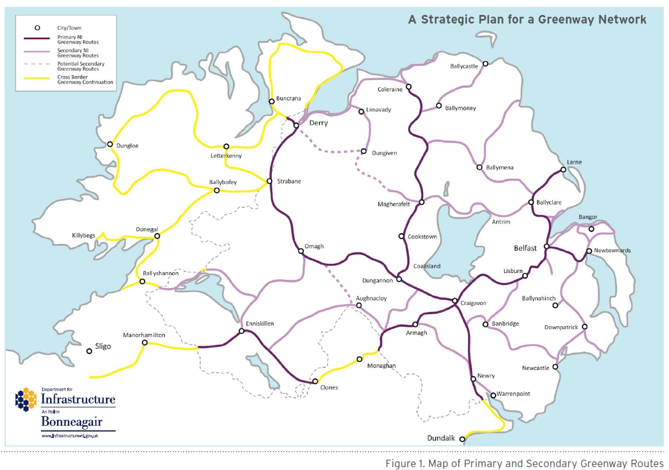
A similar Greenways Strategy is being developed for the Republic of Ireland in 2017/18. This Strategy will be reviewed against the national Strategy when available.

